1. **Write a application that accepts two numbers, divides the first number with the second number and display the result. Hint:[ You need to handle Arithmetic Exception which is thrown when there is an attempt to divide a number by zero.]**

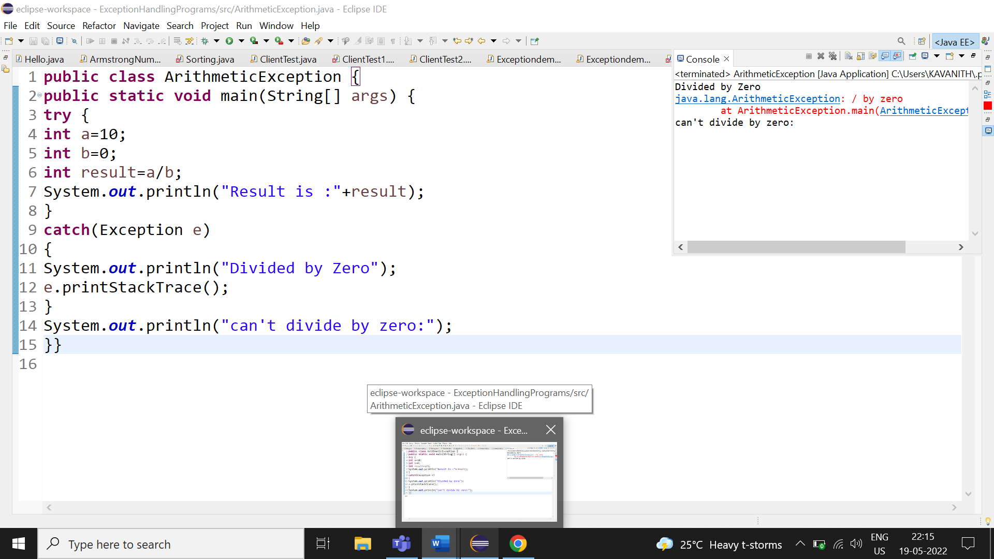

**2.Carrying forward with the above problem, handle Arithmetic Exception by raising Unsupported Operation Exception as a solution.** 